Elements of a cognitive system: - 22

1. Infrastructure and deployment modalities
2. Data access, meta data and management
3. The corpus, taxonomies and data catalog
4. Data analytics services
5. Continuous machine learning
6. Hypothesis generation and evaluation
7. Tools and learning process
8. Presentation and visualization process
9. Cognitive applications

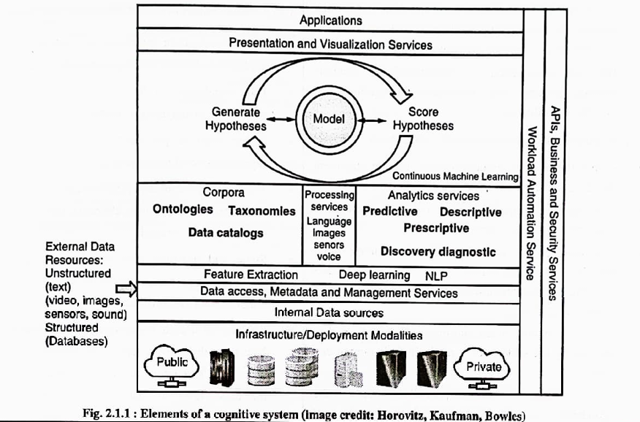

Design Principles

1. Identify
2. Define
3. Brainstorm
4. Prototype
5. Implement
6. Evaluate
7. Ensure

Design principles for cognitive systems provide a structured approach to developing intelligent systems that can mimic or simulate human-like cognitive processes. The steps you mentioned—Identify, Define, Brainstorm, Prototype, Implement, Evaluate, and Ensure—align with this approach and represent key stages in the development process:

1. **Identify:**

- In the initial stage, you identify the problem or opportunity that a cognitive system could address. This often involves recognizing areas where human-like cognition can be beneficial, such as natural language understanding, decision-making, or pattern recognition.

2. **Define:**

- After identifying the problem, you define the objectives, goals, and requirements of the cognitive system. This stage clarifies what the system should achieve and what success looks like. It may also involve understanding the target audience or users of the system.

3. **Brainstorm:**

- Brainstorming involves generating ideas and potential solutions for how to create the cognitive system. This can include considering different approaches, technologies, and algorithms that could be used to achieve the defined objectives.

4. **Prototype:**

- In this phase, you create a preliminary version of the cognitive system, often referred to as a prototype. The prototype is a working model that may not have all the features of the final system but demonstrates key capabilities. It helps in visualizing and testing concepts.

5. **Implement:**

- Implementation is the stage where you develop the full-scale cognitive system based on the insights gained from the prototype. This involves writing code, integrating components, and building the complete system.

6. **Evaluate:**

- After implementing the system, it's important to assess its performance and effectiveness. Evaluation can involve testing, validation, and user feedback. You measure how well the system meets the defined objectives and user needs.

7. **Ensure:**

- Ensuring the cognitive system's reliability, security, and ethical considerations is critical. It includes addressing issues related to data privacy, system vulnerabilities, and unintended consequences. You also need to ensure that the system complies with relevant regulations and ethical standards.

These principles provide a structured and iterative approach to designing cognitive systems, allowing for continuous improvement and refinement. Throughout the process, there is a strong emphasis on user-centered design, as cognitive systems often interact with and assist humans. Additionally, ethical and responsible development is a key consideration to ensure that cognitive systems operate safely and ethically within their intended domains.

Knowledge representation in cognitive systems refers to the way information is structured, organized, and stored within a computational system to enable it to reason, learn, and make decisions. This representation is crucial for mimicking human-like cognitive processes, as it allows the system to understand and manipulate complex knowledge, draw inferences, and solve problems.

TAXONOMIES:  
A taxonomy is a hierarchical classification system that organizes and categorizes objects, concepts, or information into a structured framework based on shared characteristics or properties. Taxonomies are used in various fields to facilitate organization, retrieval, and understanding of complex information.

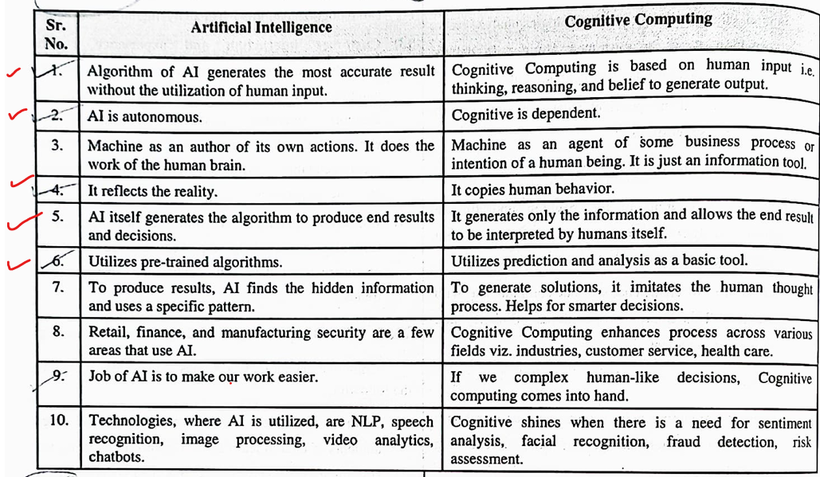

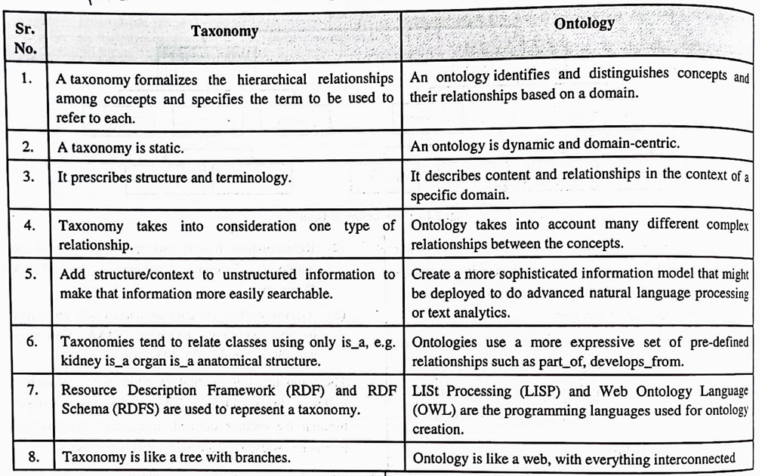

| **Aspect** | **Data Mining** | **Statistics** | **Machine Learning** |
| --- | --- | --- | --- |
| Objective | Discover hidden patterns, relationships, and knowledge within data. | Describe, analyze, and draw inferences from data. | Develop algorithms that can learn from data and make predictions or decisions. |
| Nature | Application-oriented; focuses on extracting useful information from data. | Science-oriented; seeks to understand data through probabilistic models and hypothesis testing. | Engineering-oriented; builds computational models that generalize from data. |
| Data Usage | Typically deals with large datasets and focuses on patterns that may not be apparent through simple observation. | Uses data for inference and hypothesis testing, often with a focus on smaller, well-designed samples. | Relies on data for training models and making predictions. |
| Exploratory vs. Confirmatory | Primarily exploratory, with the goal of uncovering new insights and knowledge. | Can be both exploratory and confirmatory, depending on the research question and hypothesis. | Primarily confirmatory, with a focus on building models that make accurate predictions. |
| Tools and Techniques | Utilizes a wide range of tools, including clustering, association rule mining, and anomaly detection. | Utilizes statistical methods like regression, hypothesis testing, and analysis of variance. | Utilizes algorithms like decision trees, neural networks, and support vector machines. |
| Data Preparation | Requires data preprocessing steps to clean, transform, and prepare the data for analysis. | Data is carefully collected and often requires manual or automated data cleaning. | Requires data preprocessing for feature engineering and model training. |
| Domain Application | Applied in various domains, including business, healthcare, finance, and marketing. | Widely used in scientific research and social sciences, such as psychology and economics. | Applied across diverse fields, including image recognition, natural language processing, and recommendation systems. |
| Emphasis on Inference | Inference is not the primary focus; instead, it aims to find patterns and associations in data. | Strong emphasis on statistical inference and making statements about population parameters. | Focuses on predictive accuracy and may not emphasize inference about the underlying data distribution. |
| Data Interpretation | Results may not always lead to a straightforward interpretation, as the emphasis is on patterns and relationships. | Requires a clear interpretation of statistical measures and tests, often involving confidence intervals and p-values. | Interpretation may focus on the model's performance, such as the importance of features and prediction results. |